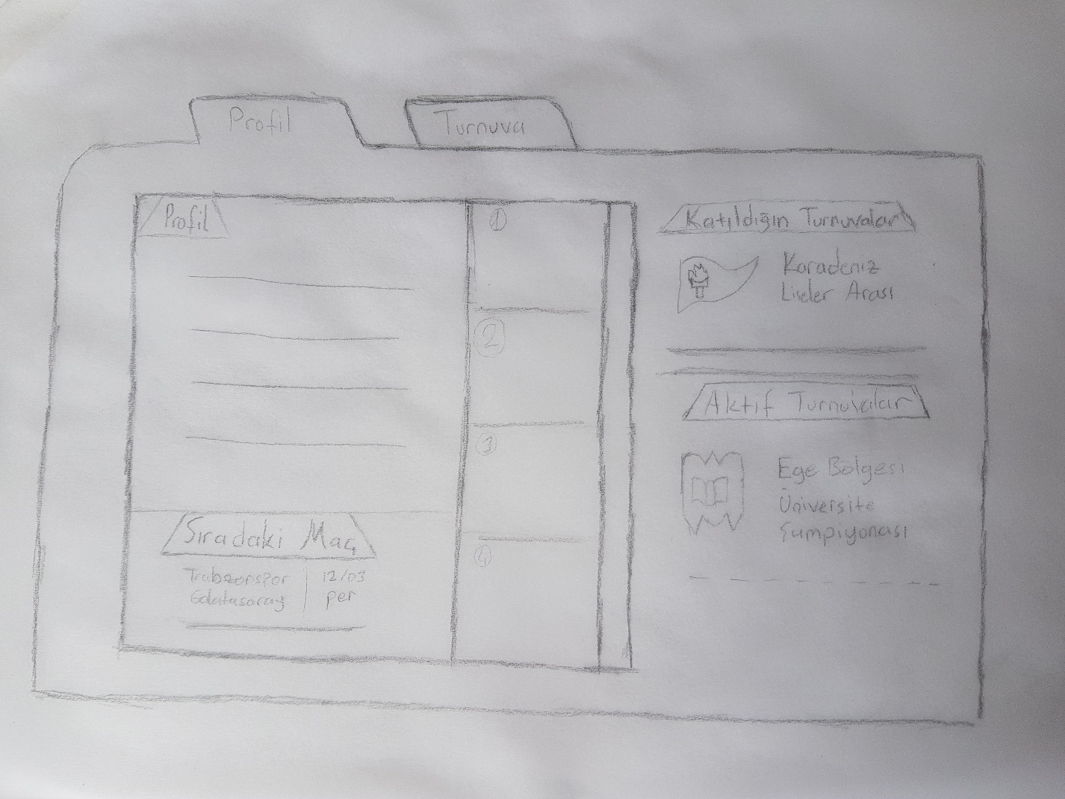

Player’s profile

The player can see his next match. Also can see when to play. (Day&hour)

Shows which tournaments are active and participated

-This area shows team ranking.

-Player’s team rank number is greater than other team’s rank number to be more understandable at first look.

**2. Esports Screen UI Mockup**

Buttons to pass between the pages.

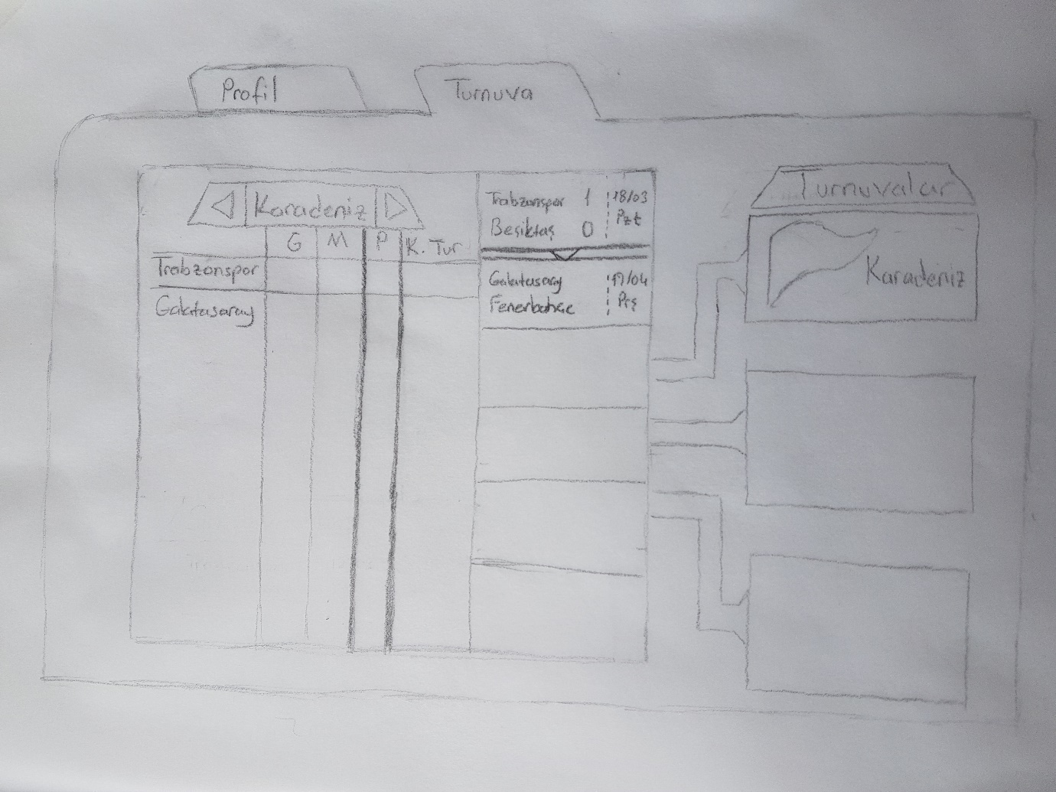

The league status shows win, lose, points and wining round (like in football’s avarege system).

User can see match schedule. First match is played then most recent match can be seen.

User can see and switch tournaments with these buttons.

With this buttons user can pass between tournaments and can see scores of teams in different tournaments.